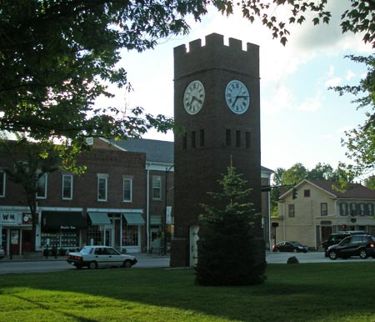
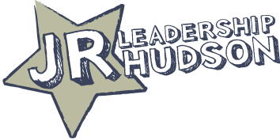

JUNIOR LEADERSHIP HUDSON
CLASS OF 2014-2015
OVERVIEW

- INTRODUCTION

Welcome to Junior Leadership Hudson! This is an exceptional program that will allow you to have experiences, develop skills, build relationships, and forge connections that will help you become a successful leader going forward. This program began in the 2009-2010 school year as the project that was created by the Leadership Hudson group, class of 2009. The purpose is to develop young leaders for Hudson or wherever our students may land in the future.

The adult leadership group is comprised of a number of adults who volunteer their time to the students and Junior Leadership Hudson to ensure we have young adults who are ready to learn, give back, and create in the community around them. The adult leaders for this year are as follows:

Mr. Chuck Wiedie (Leadership Hudson, Class of 2009), Hudson Economic Development
Mr. Kevin Altomare (Leadership Hudson, Class of 2009), Hudson’s Restaurant
Mr. Bryan Bedford, Unit Principal, Hudson High School
Mrs. Jan Neff, Teacher, Hudson High School
Mrs. Kathy Cybulski, Retired Teacher, Hudson High School
Mrs. Kim Barsella, Teacher, Western Reserve Academy
Mrs. Annie Neill, Dean of Students, Western Reserve Academy

- SYLLABUS
Activities for the year are centered around seven full-day sessions in which JLH students and advisors will explore leadership within local and regional organizations. In addition, there may be other evening or weekend commitments, depending on the project that is selected by the group. It is essential that all members commit to attending all sessions and meetings, unless a legitimate reason is presented to an advisor. Full day sessions will typically begin at 7:30 or 8:00 a.m. and end around 3:30 p.m., although extended travel could cause later return times.

2014 - 2015 Sessions
Date | Location(s) | Organizations/ Events | Purpose
September | Hudson Town Hall | City Government, Walking Tour, All- State, Project Brainstorm | Civic Leadership, Team Building, Project Initiation
October | Cleveland | Progressive Field, Sherwin Williams, Key Bank, Eaton | Professional Athletics, Business, and Finance
November | Hudson | Hudson Job Search, Interviews, Career Panel | Hone Skills, Small Business Success
December | Kent, Akron | KSU, Kent City, Akron U, Business Accelerator | Higher Education, City Government, and Entrepreneurship
January | Akron | Prosecutor, Criminal Law, Bricco, Hudson Business | Legal Field, Entrepreneurship, Business
February | Columbus | House and Senate, Business Initiative | State Government and Leadership
April | Cleveland | Cleveland Clinic, Museum, CWRU, Hudson Business | Medicine, Art, Higher Education, and Business

- The above dates and activities are a draft for the year as of August 20, 2014. The dates for each of these sessions will be made available shortly.
- Additionally, there will be a graduation evening event in May, which includes dinner in Hudson and a presentation of the JLH project

- PURPOSE/VISION

JLH makes multiple trips to Cleveland, areas in Northeast Ohio, and to Columbus, as well as having sessions in our hometown of Hudson. In the past, the experiences have included visits with people who are leaders in Government, Law, Research, Medicine, Business, Entrepreneurship, Higher Education, etc. Some examples include visits with State Legislators in Columbus, Judges and Entrepreneurs in Akron, Business Leaders in Hudson, and Officials/Managers with the Federal Reserve, Key Bank, Eaton, the Indians, Rock and Roll Hall of Fame, Museum of Art, and researchers at the Cleveland Clinic in Cleveland.

Each visit is geared around:
a. learning about the organization
b. understanding the background and training of the presenters
c. exploring leadership styles within the organization
We also do team building with the JLH students, and each year, the group takes on a project to serve the community. Time is set aside during our meetings to work on the project, although sometimes evening meetings are scheduled as well.

The experience is a great one, and one in which invaluable skills are learned. Students are also able to work with students from other schools, while meeting and networking with key figures around the state. The composition of Western Reserve Academy and Hudson High School students lends itself to collaboration for the betterment of our community. Additionally, it is our experience that the skills JLH students acquire during this year-long program benefit the schools, as the students play leadership roles in Student Government and other organizations throughout the year.

